Pacific Trails Resort

See [Chapter 2](https://jigsaw.vitalsource.com/books/9780134801346/epub/OPS/xhtml/fileP7001014793000000000000000000004.xhtml#P7001014793000000000000000000004) for an introduction to the Pacific Trails Case Study. [Figure 2.39](https://jigsaw.vitalsource.com/books/9780134801346/epub/OPS/xhtml/fileP700101479300000000000000000058B.xhtml#P70010147930000000000000000008B7) shows a site map for Pacific Trails. The Home page and Yurts page were created in earlier chapters. Using the existing website as a starting point, you will modify the design of the pages to display a large image on each page, as indicated in the wireframe in [Figure 4.51](https://jigsaw.vitalsource.com/books/9780134801346/epub/OPS/xhtml/fileP7001014793000000000000000002E5C.xhtml?favre=brett#P700101479300000000000000000315B). You will also create a new page, the Activities page.

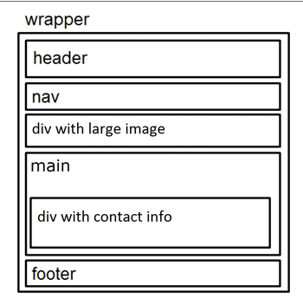

**New Pacific Trails wireframe**

You have five tasks in this case study:

1. Create a new folder for this Pacific Trails case study, and obtain the starter image files.
2. Modify the Home page to display a logo image and scenic photograph as shown in [Figure 4.52](https://jigsaw.vitalsource.com/books/9780134801346/epub/OPS/xhtml/fileP7001014793000000000000000002E5C.xhtml?favre=brett#P7001014793000000000000000003168).

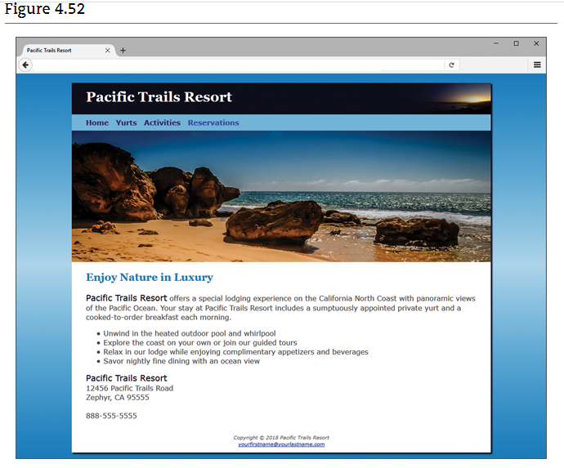

 New Pacific Trails Resort Home page

1. Modify the Yurts page to be consistent with the Home page.
2. Create a new Activities page, as shown in [Figure 4.53](https://jigsaw.vitalsource.com/books/9780134801346/epub/OPS/xhtml/fileP7001014793000000000000000002E5C.xhtml?favre=brett#P7001014793000000000000000003174).

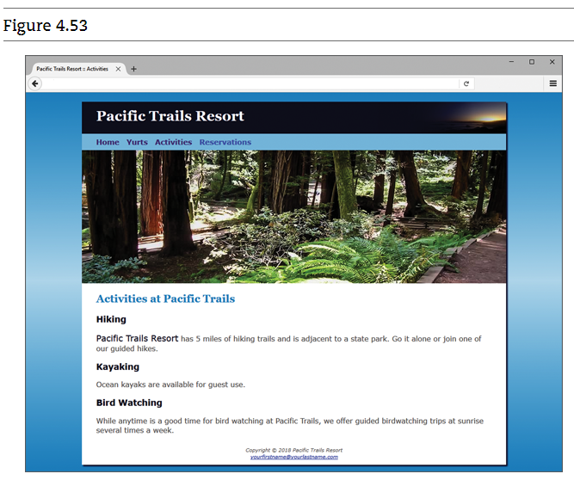 Pacific Trails Resort activities.html

1. Modify the style rules in the pacific.css file as needed.

Hands-On Practice Case

* **TASK 1: THE WEBSITE FOLDER.**Create a folder on your hard drive or portable storage device called pacific4. Copy all the files from your [Chapter 3](https://jigsaw.vitalsource.com/books/9780134801346/epub/OPS/xhtml/fileP7001014793000000000000000001DBA.xhtml#P7001014793000000000000000001DBA) pacificcss folder into the pacific4 folder. Obtain the images used in this case study from the student files. The images are located in the chapter4/­casestudystarters/pacific folder. The images are sunset.jpg, coast.jpg, yurt.jpg, and trail.jpg. Save the files in your pacific4 folder.
* **TASK 2: THE HOME PAGE.**Launch a text editor, and open the index.html file from your pacific4 folder. Modify the index.html file to look similar to the web page shown in [Figure 4.52](https://jigsaw.vitalsource.com/books/9780134801346/epub/OPS/xhtml/fileP7001014793000000000000000002E5C.xhtml?favre=brett#P7001014793000000000000000003168). Configure a div element to display the coast.jpg image. Code an opening div tag assigned to the id named homehero after the closing nav tag. Next, code a closing div tag. As shown in the wireframe in [Figure 4.51](https://jigsaw.vitalsource.com/books/9780134801346/epub/OPS/xhtml/fileP7001014793000000000000000002E5C.xhtml?favre=brett#P700101479300000000000000000315B), this div is located between the nav element and the main element. There is no HTML or text content for this div. The purpose of this div is to display a large image (configured with CSS in Task 5).

Save and validate your new index.html page. It will not yet be similar to [Figure 4.52](https://jigsaw.vitalsource.com/books/9780134801346/epub/OPS/xhtml/fileP7001014793000000000000000002E5C.xhtml?favre=brett#P7001014793000000000000000003168); you’ll configure CSS in Task 5.

* **TASK 3: THE YURTS PAGE.**Launch a text editor, and open the yurts.html page from your pacific4 folder. Configure a div element to display the yurt.jpg image. Code an opening div tag assigned to the id named yurthero after the closing nav tag. Next, code a closing div tag. As shown in the wireframe in [Figure 4.51](https://jigsaw.vitalsource.com/books/9780134801346/epub/OPS/xhtml/fileP7001014793000000000000000002E5C.xhtml?favre=brett#P700101479300000000000000000315B), this div is located between the nav element and the main element. There is no HTML or text content for this div. The purpose of this div is to display a large image (configured with CSS in Task 5). Save and validate your new yurts.html page.
* **TASK 4: THE ACTIVITIES PAGE.**Use the Yurts page as the starting point for the Activities page. Launch a text editor, and open the yurts.html file in the pacific4 folder. Save the file as activities.html. Modify the activities.html file to look similar to the Activities page, as shown in [Figure 4.53](https://jigsaw.vitalsource.com/books/9780134801346/epub/OPS/xhtml/fileP7001014793000000000000000002E5C.xhtml?favre=brett#P7001014793000000000000000003174):
  1. Change the page title to an appropriate phrase.
  2. Change the text in the <h2> to be “Activities at Pacific Trails”.
  3. Modify the div assigned to the id yurthero. Replace yurthero with trailhero.
  4. Delete the description list from the page.
  5. Configure the following text, using h3 tags for the headings and paragraph tags for the sentences:

**Hiking**

* + - Pacific Trails Resort has 5 miles of hiking trails and is adjacent to a state park. Go it alone or join one of our guided hikes.

**Kayaking**

* + - Ocean kayaks are available for guest use.

**Bird Watching**

* + - While anytime is a good time for bird watching at Pacific Trails, we offer guided birdwatching trips at sunrise several times a week.
  1. Configure a span element to contain the phrase “Pacific Trails Resort” in the first paragraph on the page. Assign the span to the class named resort.

Save the activities.html file. If you test your page in a browser, you’ll notice that it looks different from [Figure 4.53](https://jigsaw.vitalsource.com/books/9780134801346/epub/OPS/xhtml/fileP7001014793000000000000000002E5C.xhtml?favre=brett#P7001014793000000000000000003174); you still need to configure style rules.

* **TASK 5: CONFIGURE THE CSS.**Open pacific.css in in a text editor. Edit the style rules as follows:

1. Modify the body element selector style rules. Change the background color to #3399CC. Configure a CSS gradient with three color stops as the background image as shown here:  
   background-image: linear-gradient(to bottom, #3399CC, #C2E0F0, #3399CC)
2. Modify the style rules for the wrapper id. Configure the background color to be #FFFFFF. Configure a minimum width of 700px (use min-width). Configure a maximum width of 1024px (use max-width). Use the box-shadow property to configure a drop-shadow effect.
3. Modify the style rules for the h1 element selector. Configure the sunset.jpg as a background image that displays on the right and does not repeat. Set left padding to 2em. Configure a 72-pixel height (the same height as the background image).
4. Modify the style rules for the nav element selector. Set top, right, and bottom padding to .5em. Set left padding to 2em.
5. Modify the style rules for the footer element selector. Set padding to 1em.
6. Add a new style rule for the h3 element selector to display #000033 text color.
7. Add a new style rule for the main element selector that configures 2em of left and right padding. You may need to nudge Internet Explorer to display the page as intended by adding the display: block; declaration (see [Chapter 6](https://jigsaw.vitalsource.com/books/9780134801346/epub/OPS/xhtml/fileP70010147930000000000000000039B1.xhtml#P70010147930000000000000000039B1)).
8. Add a new selector for an id named homehero. Code declarations to configure 300px height and to display the coast.jpg background image to fill the space (use background-size: 100% 100%;) without repeating.
9. Add a new selector for an id named yurthero. Code declarations to configure 300px height and to display the yurt.jpg background image to fill the space (use background-size: 100% 100%;) without repeating.
10. Add a new selector for an id named trailhero. Code declarations to configure 300px height and to display the trail.jpg background image to fill the space (use background-size: 100% 100%;) without repeating.
11. Code a new style rule to prevent the hyperlinks in the nav area from displaying the default underline. Use nav a { text-decoration: none; }
12. Save the pacific.css file. Test your pages (index.html, yurts.html, and activites.html) in a browser. Your pages should look similar to [Figures 4.52](https://jigsaw.vitalsource.com/books/9780134801346/epub/OPS/xhtml/fileP7001014793000000000000000002E5C.xhtml?favre=brett#P7001014793000000000000000003168) and [4.53](https://jigsaw.vitalsource.com/books/9780134801346/epub/OPS/xhtml/fileP7001014793000000000000000002E5C.xhtml?favre=brett#P7001014793000000000000000003174) except that you’ll see some extra space between the header and navigation area. Let’s do something about that. We’ll need to use the CSS margin property, which you’ll explore in depth in [Chapter 6](https://jigsaw.vitalsource.com/books/9780134801346/epub/OPS/xhtml/fileP70010147930000000000000000039B1.xhtml#P70010147930000000000000000039B1). Modify the style rules for the h1 selector to set the bottom margin to 0 with the following code:

**margin-bottom: 0;**

Save the pacific.css file. Test your pages (index.html, yurts.html, and activities.html) in a browser. The Home page (index.html) should look similar to [Figure 4.52](https://jigsaw.vitalsource.com/books/9780134801346/epub/OPS/xhtml/fileP7001014793000000000000000002E5C.xhtml?favre=brett#P7001014793000000000000000003168). The new Activities page (activities.html) should look similar to [Figure 4.53](https://jigsaw.vitalsource.com/books/9780134801346/epub/OPS/xhtml/fileP7001014793000000000000000002E5C.xhtml?favre=brett#P7001014793000000000000000003174). If your images do not appear, examine your work carefully. Use Windows Explorer or Mac Finder to verify that the images are saved in your pacific4 folder. Examine your CSS to be sure you spelled the image names correctly. Another useful troubleshooting technique is to validate the HTML and CSS code.